**Using Pentbox on Kali Linux: A Simple Guide**

**What is Pentbox?**

Pentbox is a tool for testing security on Kali Linux. It helps find weaknesses in networks and systems. This guide explains how to set it up and use it.

**Why Use Pentbox and Honeypots?**

**Honeypots** are fake systems used to catch attackers. They:

* Show how hackers try to break into systems.
* Help fix weaknesses in your real network.
* Distract hackers from the main network.

**What You Need**

Before you start, make sure you have:

1. **VirtualBox** for running virtual machines.
2. **Kali Linux** installed.
3. **Pentbox** downloaded.

**Download and Install Pentbox on Kali Linux**

Pentbox, a Ruby-based application, offers various network and cryptographic functionalities. Here's how to install it on Kali Linux:

Terminal -Bash

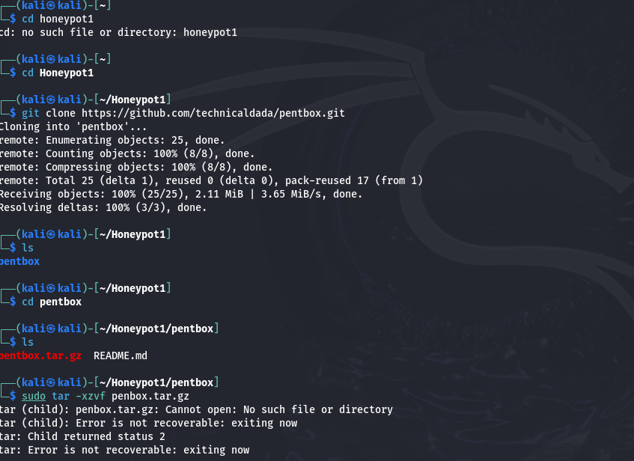

**Pentbox Features**

**When you open Pentbox, you'll see a menu with these options:**

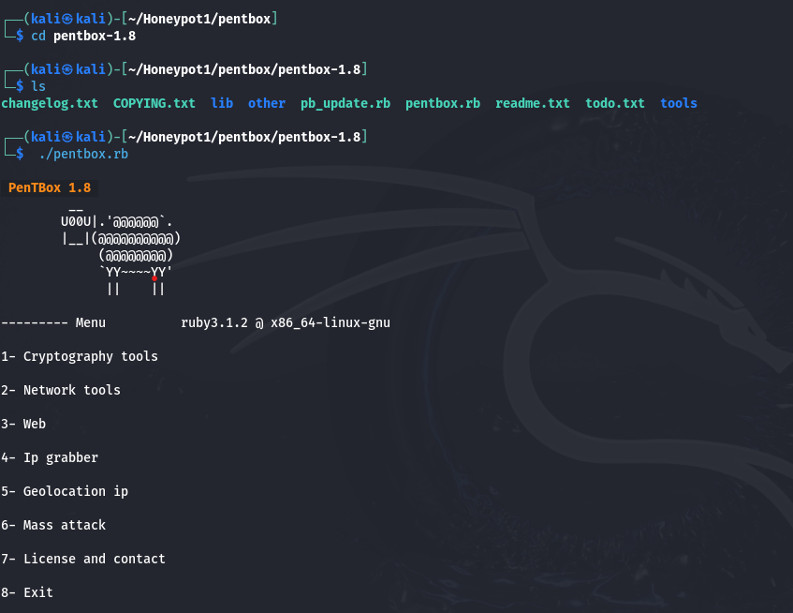

**1. Network Tools**

* **Honeypot**: Sets up a fake system to catch hackers.
  + Fast Setup: Quickly configures on port 80.
  + Manual Setup: Lets you choose ports, messages, and logs.
* **Port Scanner:** Finds open ports on an IP or website.
* **Network Flooder:** Sends lots of traffic to test network strength (use carefully).

**2. Cryptography Tools**

* **Hashing Tools:** Creates secure codes (MD5, SHA256) for data.
* **Password Cracking:** Tries to guess passwords using a word list.
* **Text Encryption:** Protects text by encoding it with a key.

**3. System Tools**

* Checks basic system performance.

**Exploring Network Tools in Detail**

**1. Port Scanner**

* Navigate to Network Tools menu.

* Select TCP Port Scanner

* Enter a target IP or hostname to scan for open ports.

**Exploring Cryptography Tools in Detail**

**1. Hashing Tools**

* Navigate to Cryptography Tools menu.

* Select Hashing Tools

* Choose a hashing algorithm (e.g., MD5, SHA256) and provide input.

**2. Password Cracking**

Navigate to Cryptography Tools menu.

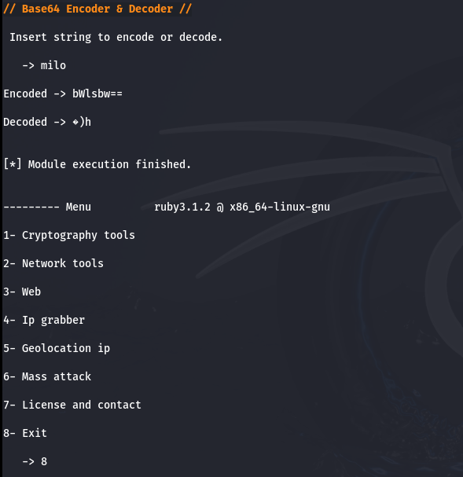

**3. Secure Text Encryption**

Navigate to Cryptography Tools menu.

* Input text and a key for encryption or decryption.

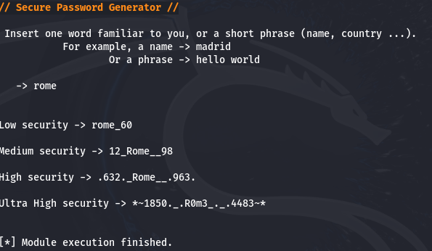

**Test Cases for Pentbox Commands**

**Honeypot Testing**

* Use a browser or Telnet client to simulate intrusion attempts on configured ports.

* Monitor the Kali terminal for detected intrusions.

